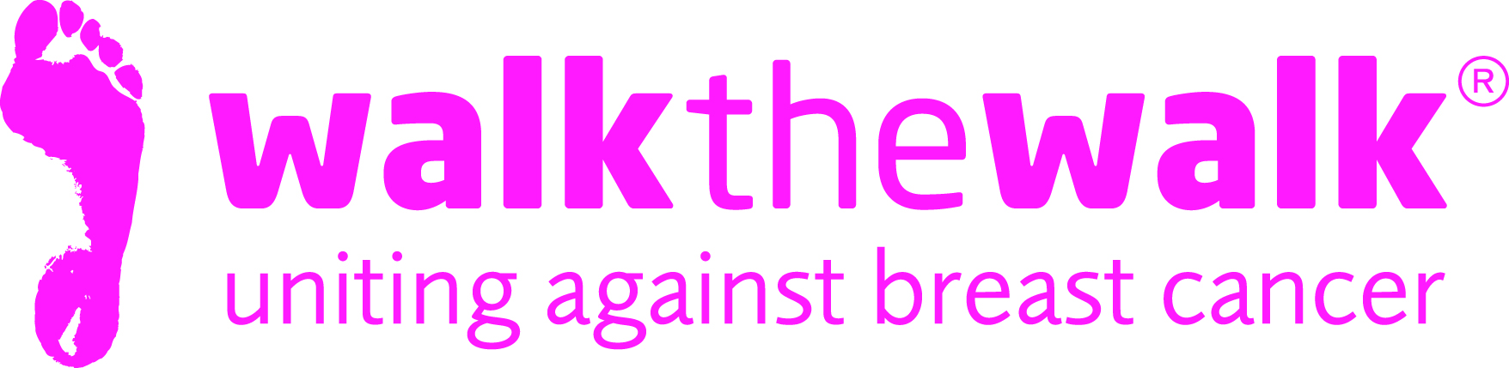

PRESS RELEASE
Bra-lliant night for Breast Cancer Awareness Month!
Wednesday 5th October
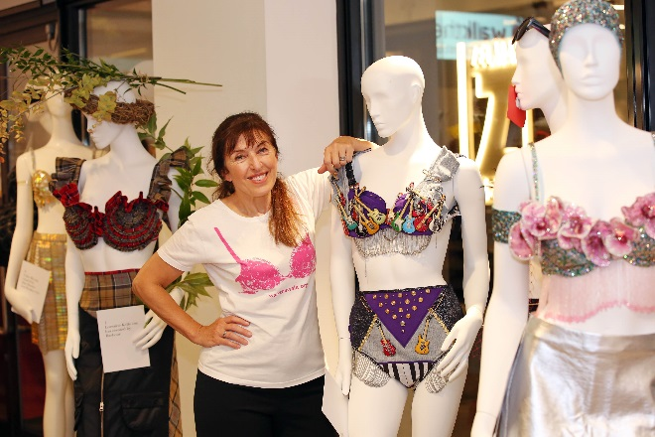

Ab Fab star Harriet Thorpe, girl group The Tootsie Rollers, and Weather Forecaster Kirsty McCabe were just three big names showing their support for breast cancer charity Walk the Walk last night (Tuesday 4th October).

The event, which marked the start of Breast Cancer Awareness Month, as well as celebrating the grant-making charity’s 20th birthday, took place at the Good Housekeeping Institute in Soho, London.

Around 70 VIP guests were treated to an exclusive exhibition of bras signed by a host of celebrities, which have been created by world-renowned designers. The collection included a Little Mix bra by Jane Bowler, an Alan Carr bra by Julien Macdonald, and an Ab Fab bra signed by Harriet Thorpe and Jennifer Saunders, created by Victoria Grant. A Lorraine Kelly bra by Barbour added a touch of Scottish charm, and a BAFTA bra by Sandy Powell gave the event some red carpet glamour. A Zandra Rhodes design, a Joey D belt design, an intriguing Nina Saunders sculpture, and a special Good Housekeeping bra completed the collection.

Talking about the Ab Fab bra, Actress Harriet Thorpe, Walk the Walk’s Ambassador said:

“The bra is eccentric, wild, classy, on-trend, with a touch of randomness – it represents the characters of Ab Fab perfectly!
I’m proud to be Ambassador of Walk the Walk. Every year I am astonished by the incredible amount of money that is raised to help combat breast cancer. Let’s keep up the good work!”
Nina Barough, Founder and Chief Executive of Walk the Walk added:
“As part of our 20 year celebrations, hosted by Good Housekeeping, Walk the Walk held an exhibition of designer bras. It was a fantastic opportunity, to not only raise awareness by displaying some of our wonderful creations, but to also talk about our hopes for the future. Over the past 20 years Walk the Walk has been able to make a significant contribution into the research and knowledge that we now have of primary cancers. Going forward our aim is to do the same to further research into secondary cancers, giving all cancer patients the same hope and opportunities.”

The bra is the trademark of Walk the Walk, and thanks to the thousands of Walkers wearing decorated bras as they take part in the charity’s MoonWalks, and other events, more than £113 million has been raised for breast cancer causes.
Since 1996, Walk the Walk has made grants to charities including; Breast Cancer Now, Penny Brohn UK, Helen Rollason Cancer Charity, Tenovus, The Haven, and The Christie Hospital. The charity also has its own special project, providing funding to hospitals across the UK to purchase Scalp Cooling systems, special machines which help many people undergoing chemotherapy to retain their hair.
Images from last night’s event are available here.
The MoonWalk London takes place on Saturday 13 May 2007. Sign up at walkthewalk.org

For more information, photographs and quotes, contact:
- Sally Orr at Walk the Walk. 07796 080 675 sally@walkthewalk.org
- Claire Duncan at Walk the Walk. 01483 741 430 claire@walkthewalk.org

Notes to Editors

The MoonWalk London 2017
- Saturday 13th May 2017, Clapham Common
- 2017 will be the 20th MoonWalk London.
- Two walking challenges are available: Half Moon (13.1 + 2 miles) or Full Moon (26.2 miles)
- This year’s theme is “The Roaring Twenties”
- All participants must be aged 13 and over to take part
- The cost of entering the Half Moon and Full Moon is £48.50
- Walkers are asked to raise a minimum of £100 in sponsorship
- Entries are open at www.walkthewalk.org

Walk the Walk
- Nina Barough CBE, Founder and Chief Executive, set up and leads the grant-making breast cancer charity Walk the Walk.
- Walk the Walk is passionate about encouraging women and men to become fitter and healthier and take control of their own wellbeing.
- In 1996, Nina woke up with the idea of Power Walking the New York City Marathon in a bra to raise money for research into breast cancer.
- Nina was diagnosed with breast cancer herself shortly afterwards, which was the starting point for Walk the Walk and the first MoonWalk London in 1998.
- Walk the Walk has now raised £113 million, which is granted to fund breast cancer research and to help improve the lives of people with cancer.
- Walk The Walk also organises the following events:- The MoonWalk Scotland (10th June 2017), The MoonWalk Iceland (17th June 2017) and The Arctic Marathon – a 26.2 mile backcountry skiing challenge in the far north of Lapland.
- Additionally, Walk the Walk takes walkers to events including the Inca Trail Peru, Berlin Marathon, New York Marathon, Paris Marathon, Dublin Marathon and the Nijmegen Marches.
- Since it launched, Walk the Walk has made grants for research to Breast Cancer Now for its Generations Study, the Legacy Study into Secondary Breast Cancer and the UK’s first ever Breast Cancer Tissue Bank.
- Walk the Walk has also funded a pilot study by charity Medical Detection Dogs to investigate if dogs that can already smell cancers, can distinguish breast cancer from other types of cancer.
- Grants from Walk the Walk have also been made to the following charities, to help improve the lives of people with cancer: Maggie’s Cancer Care Centres, Penny Brohn UK, Tenovus, The Haven, The Christie Hospital, Helen Rollason Cancer Charity
- For more information, and to sign up for all Walk the Walk’s challenges, as a Walker or a Volunteer, go to www.walkthewalk.org

