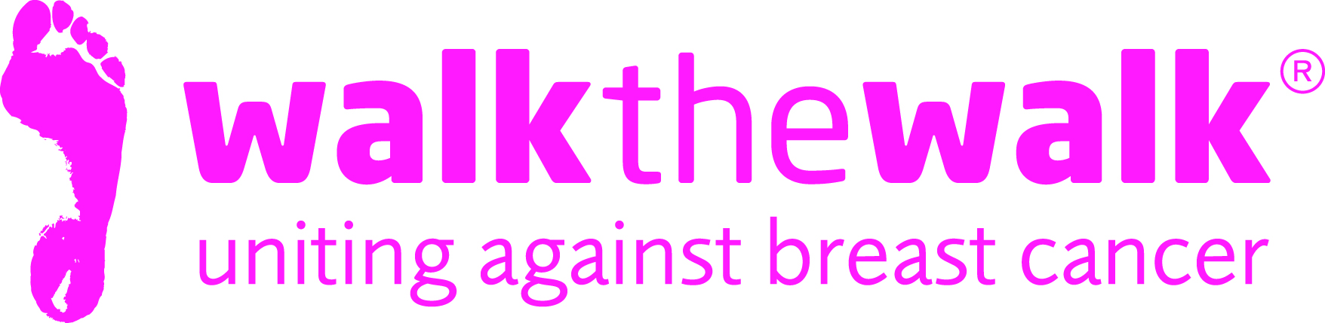
PRESS RELEASE
Boomerang-A-MoonWalk!
Bay City Rollers support iconic charity event
The Bay City Rollers are showing their support for The MoonWalk Scotland 2016, by allowing charity Walk the Walk to use the yet to be released single “Boomerang” as the backing music for their current radio adverts.
Starting this year from its historic new home, Holyrood Park, Scotland’s much loved challenge will see thousands of Young Walkers, Women and Men walk through the streets of Edinburgh at Midnight on Saturday 11th June. Wearing the charity’s trademark decorated bras, everyone will be uniting to raise money and awareness for breast cancer.
With this year’s “Swing your Tartan” MoonWalk theme, everyone really will be partying Scottish style! How apt then, that Scotland’s legendary tartan rockers, who have just performed sell out reunion gigs in Glasgow and Edinburgh, are supporting the iconic MoonWalk.
John McLaughlin, manager of The Bay City Rollers said : “We’re ecstatic to lend our support to such a fantastic charity, which has done so much great work over the years. My own wife Sharon has taken part in The MoonWalk Scotland herself, and I’ve seen what happens on the night at first hand. It’s a truly wonderful event.”
Poster Girls Gael Roy, Jackie Wyllie, Claire Vickers and Julie Sinclair are featured sporting tartan in publicity material for this year’s MoonWalk Scotland. A pdf of the poster, plus the original image is available to download here.
Gael Roy said: “We are delighted to be poster girls for such a fantastic event. We take part year on year, as not only is it a personal challenge, but it helps raise money for such a wonderful charity which has supported people close to us. It is very well organised, great fun and the atmosphere on the night is second to none. I would highly recommend signing up, it’s a great accomplishment and you’ll raise much needed funds for such a brilliant cause.”
This year, breast cancer charity Walk the Walk is celebrating 20 years of Walking the Walk. Millions of pounds have already been granted towards groundbreaking research and to help those that have cancer in Scotland. The charity is not only dedicated to raising awareness and money for breast cancer causes, but is also passionate about encouraging women and men of all ages to set their own goal and to take more responsibility for their own well-being.
To sign up for The MoonWalk Scotland, either as a Walker or a Volunteer, go to www.walkthewalk.org
ENDS

Notes to editors:
For more details, spokespeople, case studies and images, contact:-
- Sally Orr at Walk The Walk 07796 080675 sally@walkthewalk.org
- Jennifer McAllister at Walk the Walk 01483 741430 jennifermc@walkthewalk.org
The MoonWalk Scotland 2016

- Saturday 11th June 2016, Holyrood Park
- Four walking challenges are available: New Moon (6.55 miles) Half Moon (13.1miles) Full Moon (26.2 miles) or Over the Moon (52.4 miles)
- This year’s theme is “Swing Your Tartan”
- The New Moon costs £32.50 for adults and £15.00 for Young Walkers aged 10-12
- The cost of entering the Half Moon and Full Moon is £47.50 – minimum age 13
- The cost of entering the Over the Moon is £72.50 – minimum age 18
- Walkers are asked to raise a minimum of £100 in sponsorship.
- Entries are now open at www.walkthewalk.org
Walk the Walk
- Nina Barough CBE, Founder and Chief Executive, set up and leads the grant-making, health charity Walk the Walk.
- Walk the Walk is passionate about encouraging women and men to become fitter and healthier and take control of their own wellbeing.
- The MoonWalk Scotland has raised more than £18 million since 2006, with most of the money raised staying in Scotland to help improve the lives of people with cancer.
- Walk the Walk has made grants in Scotland to Maggie’s Cancer Care Centres in Glasgow, Larbert and Airdrie, and to the Breast Cancer Institute in Edinburgh (renovation of Ward 6, a new theatre and renovation of the Mammography Unit).
- Walk the Walk is committed to providing funding to hospitals across Scotland and the UK to purchase Scalp Cooling systems, special machines which are helping many people undergoing chemotherapy to retain their hair.
- Walk The Walk also organises the following Power Walking events:- The MoonWalk London (14th May 2016), The MoonWalk Iceland (18th June 2016)
- Walk the Walk is the organiser of The Arctic Marathon – a 26.2 mile backcountry skiing challenge in the far north of Lapland.
- Additionally, Walk the Walk takes walkers to events including the Inca Trail Peru, Berlin Marathon, Paris Marathon, New York Marathon and the Nijmegen Marches.
- For more information, and to sign up for all Walk the Walk’s challenges, as a Walker or a Volunteer, go to www.walkthewalk.org
Bay City Rollers

