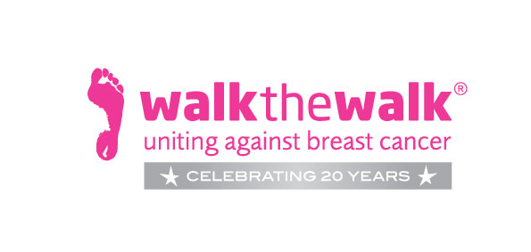

PRESS RELEASE

Love Walking, Love Life… Love Chocolate!

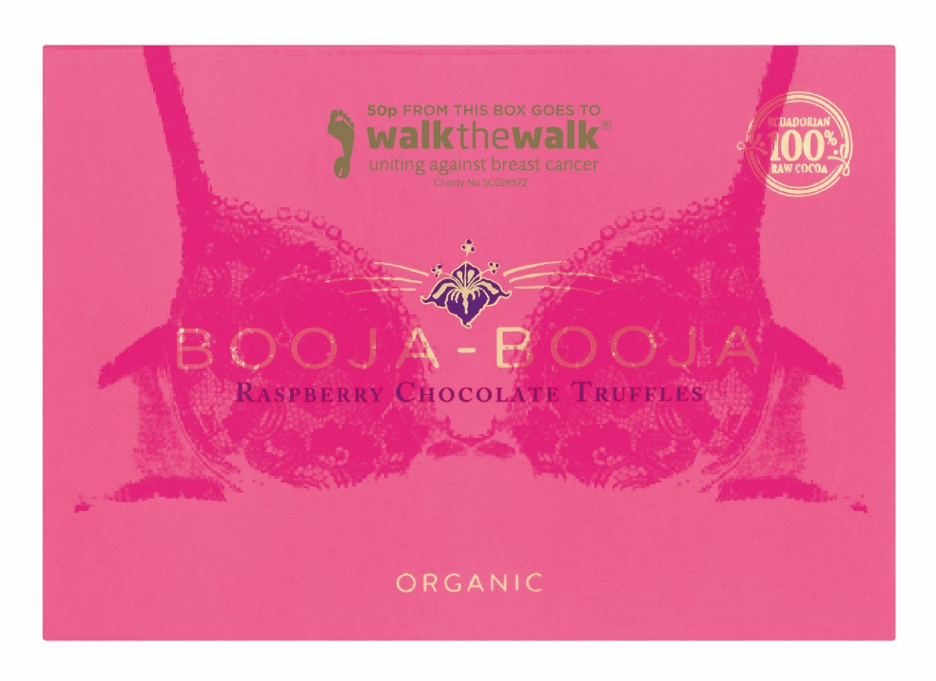
Award-winning organic confectioner Booja-Booja is raising money for leading breast cancer charity Walk the Walk by producing limited edition boxes of their melt in the mouth Raspberry Chocolate Truffles. Each special box will sport a bra, just like the women and men who take part in Walk the Walk’s famous MoonWalk events in London, Scotland and Iceland. Booja-Booja is donating 50p to the charity for every box sold.

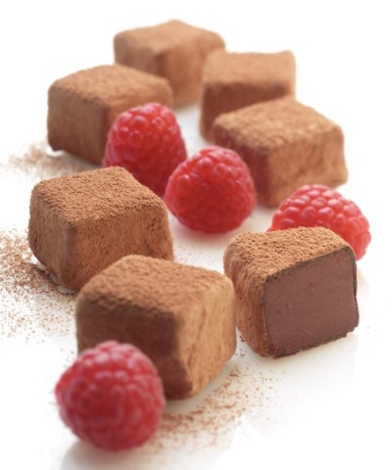
The launch of this limited edition box marks the beginning of what Booja-Booja and Walk the Walk both hope will be an exciting and fruitful long-term relationship. The two organisations share many similar values and are both dedicated to helping people make healthier choices in their everyday lives.

Walk the Walk organises power walking events in the UK and beyond, giving people the chance to improve their fitness while having fun and raising vital funds for breast cancer research, prevention and care. Booja-Booja is a pioneer in health-aware deliciousness, creating dairy free chocolate truffles and ice cream that are organic, dairy, gluten and soya free and made with the minimal number of simple ingredients. The Raspberry Chocolate Truffles, along with the company’s Dark Ecuadorian Truffles and all of the dairy free ice cream range, are made without refined sugar.

Booja-Booja MD David Abbott says "We are very excited about creating this partnership with Walk the Walk and working closely with them going forward. We have thoroughly enjoyed developing these eye catching, limited edition boxes which we hope will encourage our customers to support the fantastic work of Walk the Walk while enjoying truly delicious healthier chocolate truffles.”
Nina Barough CBE, Founder and Chief Executive of Walk the Walk “We are all absolutely delighted and very excited about our partnership with Booja-Booja. What a very lovely and delicious way to support Walk the Walk and to raise awareness for breast cancer by creating these special limited edition boxes of Raspberry Chocolate Truffles."

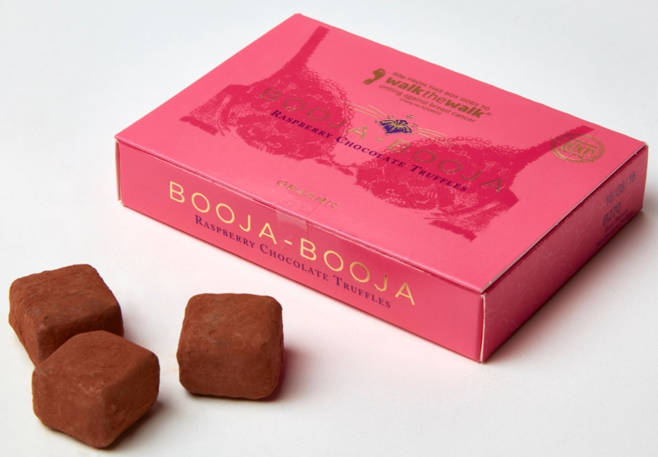

As well as being popular with anyone who’s ever power-walked in a decorated bra, both organisations hope that the limited edition boxes will help to spread the Walk the Walk message to those who haven’t encountered the charity before. Fantastically festooned bras represent the spirit of Walk the Walk; now, thanks to Booja-Booja, it’s possible to support the charity by buying a box of amazingly delicious chocolate truffles that’s wearing a bra of its own!

The limited edition ‘Bra Boxes’ of Raspberry Chocolate Truffle boxes will be available from hundreds of independent health food shops, delicatessens and farm shops across the UK from The Natural Store, Falmouth in the South to Real Foods, Edinburgh (home of The MoonWalk Scotland) in the North. Plus all branches of Planet Organic and Wholefoods Market and Selfridges’ flagship Oxford Street store in London. They will also be sold online by ocado.com and goodnessdirect.co.uk. There is a stockist locator tool at www.boojabooja.com/stockists. To keep these gourmet treats at their tip-top best they are stored chilled, so they will be found in the fridge.

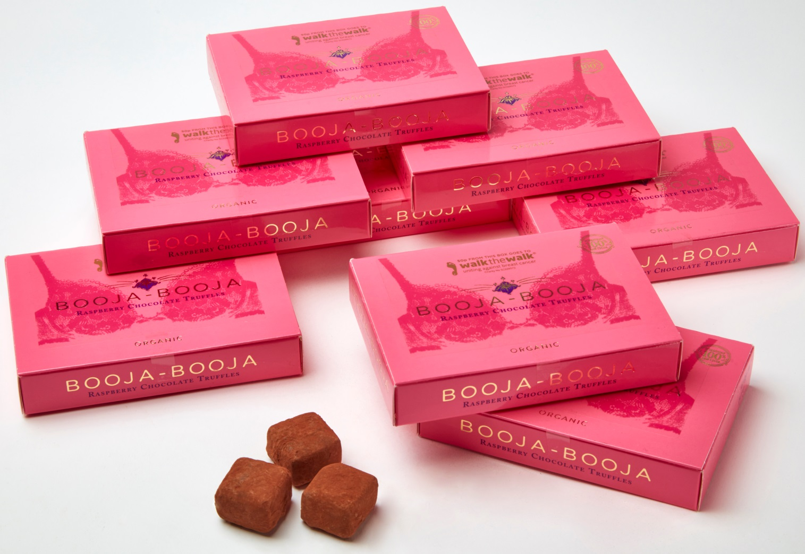

ENDS

February 2016

CONTACT

For further details about Booja-Booja please contact:

Louise Truswell - louiset@boojabooja.com
Louise Collins - louise@boojabooja.com
Booja-Booja
Brooke
Norfolk
NR15 1HJ
tel. 01508 557904
www.boojabooja.com

For further details about Walk the Walk please contact:
Sally Orr sally@walkthewalk.org 01483 741430
Jennifer McAllister jennifermc@walkthewalk.org 01483 741430

Notes to editors:

Booja-Booja
- Booja-Booja is a privately owned business which makes more than a dozen varieties of chocolate truffles and dairy free Ice Cream Alternative.
- All Booja-Booja products are made on one site in Brooke, Norfolk, England.
- All Booja-Booja products are organic; certified by The Soil Association.
- All Booja-Booja products are dairy free, gluten free and soya free.
- All Booja-Booja products are suitable for vegetarians and vegans; accredited by the Vegan Society (UK)
- Booja-Booja Chocolate Truffles and Ice Cream Alternative are available from independent wholefood shops, delicatessens, farm shops, luxury department stores, food halls and leading high street retailers across the UK and Europe.
- Booja-Booja has won 77 awards
- More details about specific flavours and collections are available on request
- More information can also be found at www.boojabooja.com

Walk the Walk
- Nina Barough CBE, Founder and Chief Executive, set up and leads the grant-making, health charity Walk the Walk.
- Walk the Walk is passionate about encouraging women and men to become fitter and healthier and take control of their own wellbeing.
- The flagship Walk the Walk event is The MoonWalk London, which will take place this year on 14th May starting at Clapham Common. Two walking challenges are available: Half Moon (13.1 + 2 miles) or Full Moon (26.2 miles)
- Walk the Walk also organises the following Power Walking events:- The MoonWalk Scotland (11th June 2016), The MoonWalk Iceland (18th June 2016) and The Arctic Marathon – a 26.2 mile backcountry skiing challenge in the far north of Lapland.
- Additionally, Walk the Walk takes walkers to events including the Inca Trail Peru, Berlin Marathon, Paris Marathon, New York Marathon and the Nijmegen Marches.
- Since it launched, Walk the Walk has made grants for research to Breakthrough Breast Cancer and Breast Cancer Campaign (for its ground-breaking Breast Cancer Tissue Bank)
- Breast Cancer Campaign and Breakthrough Breast Cancer recently merged to form Breast Cancer Now. Funding from Walk the Walk has made possible Breast Cancer Now’s Legacy Study for Secondary Breast Cancer.
- A grant has also been made for research to the Medical Detection Dogs Charity.
- Walk the Walk is also committed to providing funding to hospitals across the UK to purchase Scalp Cooling systems, special machines which are helping many people undergoing chemotherapy to retain their hair.
- Grants from Walk the Walk have also been made to the following charities, to help improve the lives of people with cancer: Maggie’s Cancer Care Centres, Penny Brohn Cancer Care, Tenovus, The Haven, The Christie Hospital, and the Helen Rollason Cancer Charity
- For more information, and to sign up for all Walk the Walk’s challenges, as a Walker or a Volunteer, go to www.walkthewalk.org

