PHOTOCALL NOTICE
Wednesday 15th March 2017
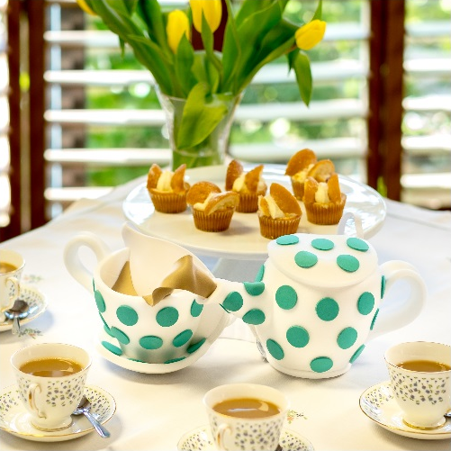
Bra-vo! New Maggie’s Centre opens, thanks to MoonWalkers!

Maggie’s “Comforting Cup of Tea” themed bra, designed for Walk the Walk

- When: Wednesday 15th March 2017, 11.30am (12.45pm for unveiling)
- Where: Maggie’s Forth Valley, Forth Valley Royal Hospital, Stirling Rd,
Larbert FK5 4WR
- What: The opening of Maggie’s Forth Valley, the 20th Maggie’s Centre, offering
free practical, emotional and social support for people with cancer and their
family and friends. Principal funder breast cancer charity Walk the Walk has
provided the £3 million needed to build the Centre from funds raised by The
MoonWalk Scotland.
- How: The Centre will be officially opened at 12.45pm by Lord Jack McConnell,
Nina Barough CBE, Founder and Chief Executive of Walk the Walk and
Maggie’s Chief Executive Laura Lee.
- Who: Interview, film and photo opportunities from 11.30am with
- Lord Jack McConnell
- Nina Barough CBE, Founder and Chief Executive of Walk the Walk
- Laura Lee, Maggie’s Chief Executive
- Liz MacMillan, Centre Head for Maggie’s Forth Valley
- Case studies
Please pre-request any interviews and previews of the new centre. Due to limited space photographers are requested to provide advance notice to take part in this photocall.

For media accreditation and arrival details on the day, contact:
- Jennifer McAllister at Walk the Walk 01483 741430 jennifermc@walkthewalk.org
- Samantha Booth at Maggie’s 07825 056394 Samantha.booth@maggiescentres.org
About Walk the Walk
- Nina Barough CBE, Founder and Chief Executive, set up and leads the grant-making breast cancer charity Walk the Walk.
- Walk the Walk is passionate about encouraging women and men to become fitter and healthier and take control of their own wellbeing.
- In 1996, Nina woke up with the idea of Power Walking the New York City Marathon in a bra to raise money for research into breast cancer.
- Nina was diagnosed with breast cancer herself shortly afterwards, which was the starting point for Walk the Walk and the first MoonWalk London in 1998. The MoonWalk Scotland followed in 2006.
- Walk the Walk has now raised £113 million, which is granted to fund breast cancer research and to help improve the lives of people with cancer. More than £19.6 million has been raised in Scotland alone.
- Walk The Walk also organises The MoonWalk London (13th May 2017), The MoonWalk Iceland (17th June 2017) and The Arctic Marathon – a 26.2 mile backcountry skiing challenge in the far north of Lapland.
- For more information, and to sign up for all Walk the Walk’s challenges, as a Walker or a Volunteer, go to www.walkthewalk.org

About The MoonWalk Scotland 2017
- Saturday 10th June 2017, Holyrood Park
- Thousands of women, men and children will walk through the streets of Edinburgh at Midnight, with those aged 13 and over wearing Walk the Walk’s trademark brightly decorated bras.
- Four walking distances are available: New Moon (6.55 miles – minimum age 10 years old); Half Moon (13.1 miles) and Full Moon (26.2 miles) – both minimum age 13 years old; Over The Moon (52.4 miles – minimum age 18 years old)
- Entries are open at www.walkthewalk.org
- Walk the Walk is the principal funder of Maggie’s Glasgow at Gartnavel Hospital, Glasgow as well as of the new centre at the Forth Valley Royal Hospital in Larbert.
- A grant was also made towards Maggie’s Lanarkshire in the grounds of Monklands Hospital in Airdrie.
- Walk the Walk has also funded the renovation of Ward 6, a new theatre and renovation of the Mammography Unit at the Breast Cancer Institute at Edinburgh’s Western General Hospital.
- Walk the Walk is committed to providing funding to hospitals across Scotland and the UK to purchase Scalp Cooling systems, special machines which are helping many people undergoing chemotherapy to retain their hair. Walk the Walk has funded 54 Scalp Coolers in 25 Scottish hospitals.

About Maggie’s Forth Valley
- Maggie’s Forth Valley will officially be opened on Wednesday 15th March in the grounds of Forth Valley Royal Hospital in Larbert.
- A full programme of support will be offered at the centre from Thursday 16th March 2017.
- The first Maggie’s Centre opened in Edinburgh in 1996 and the new Maggie’s Forth Valley Centre is the 20th to be opened.
- The Centre will be opened by Lord Jack McConnell. Maggie’s Chief Executive Laura Lee and Nina Barough CBE, Founder and Chief Executive of breast cancer charity Walk the Walk, the centre’s principal funder, will also be present.
- Maggie’s Forth Valley is a warm, uplifting Centre where anyone affected by cancer can go whenever they want. Maggie’s professionally staffed Centres are used by people at the time of diagnosis, throughout treatment and beyond and offer an enhanced, evidence-based core programme of support as well as a comprehensive service of complementary therapies including emotional, social and psychological support and benefits advice.
- The Centre has been designed by acclaimed architects Garbers & James
- Maggie’s relies on voluntary donations to support and grow its network of Centres and to develop its unique, high quality programme of support. The charity’s aim is to make the biggest difference possible to people living with cancer and their family and friends.
About Maggie’s
- Maggie’s offers free practical, emotional and social support to people with cancer and their family and friends. Built in the grounds of specialist NHS cancer hospitals, Maggie’s Centres are warm and welcoming places, with qualified professionals on hand to offer a programme of support that has been shown to improve physical and emotional wellbeing.
- Great architecture is vital to the care Maggie’s offers; and to achieve that Maggie’s works with great architects like Richard Rogers, Norman Foster and the late Zaha Hadid, whose expertise and experience deliver the calm, uplifting environments that are so important to the people who visit and work in the Centres.
- The first Maggie’s Centre opened in Edinburgh in 1996. With the opening of Maggie’s Forth Valley, Maggie’s now has 20 Centres across the UK and abroad, as well as an online Centre for support.
- Maggie’s President is HRH The Duchess of Cornwall.
- For further information about Maggie’s please go to www.maggiescentres.org

